# **CIS 36A :: Lab 2 - Data Types and Operations**

#### **Student Name:**

### **Task 1: Definitions & Concepts**

**Instructions:** Answer the questions below.

1. Keywords: To you best knowledge, briefly describe below words:
   1. Char => Like a string but just a single character.
   2. Double => Its a decimal with more data space then a float.
   3. Unicode => A code with representations for almost any character.
   4. Literal => I haven’t heard of this, but I assume it’s to be able to use certain characters out of syntax in more of a “literal” way.
   5. Identifier => Also not sure what this is, but I’m guessing it gives the ability to identify a data type by it’s data?
2. List all four integer types and write their bit and byte sizes:  
   =>
   1. byte (1 byte, 8 bits)
   2. Short (2 bytes, 16 bits)
   3. Int (4 bytes, 32 bits)
   4. Long (8 bytes, 64 bits)
3. What is the scope of a variable?   
   => Where in the class structure it is defined and can be used. It can’t be used in the superclass of where it was defined.
4. Why does Java strictly specify the range and behavior of its primitive types?  
   => It allows for Java to be easily portable across platforms and for easier debugging.
5. In general, when a cast is needed?   
   => When you’re assigning a new value to a data type it needs to be expanded to be able to accept the value.

### **Task 2: Understanding Programming**

Instructions: Answer each question below. Try to understand and explain the code.   
**Do not put an IDE code screenshot.**

1. Which of the following assignment statements are legal in Java?   
   Write **legal** or **illegal** next to them.
   1. int x = false; => illegal
   2. int x = 3 > 4; => illegal
   3. int x = 3.14; => illegal
   4. int x = 5,000,000; => illegal
   5. int x = 5_000_000; => legal
   6. int x = 'A'; => illegal
   7. int x = "A"; => illegal
   8. double d = 1E3.5; => illegal
   9. char c = '\/'; => illegal
   10. char c = '\\'; => legal
   11. char c = 3; => legal
   12. char c = "3"; => illegal
2. Which of the following expressions are legal in Java? If it is legal, give its value.   
   **Assume:** x is an int variable with the value 5,   
    y is a double variable with value 3.5,   
    b is a boolean variable with value false.
   1. (3 + 4 / 5) / 3 => 1
   2. 3 * 4 % 5 / 2 * 6 => 6
   3. 3 + x++ => 8
   4. 3 + ++x => 9
   5. 0/0 => illegal
   6. y/x => illegal
   7. 'a' + 'b' => 195
   8. 'a' + 'b' + "c" => 195c
   9. "3" + 2 + 1 => 321
   10. "3" + (2 + 1) => 33
   11. false < true => illegal
   12. false == true => false
   13. 'c' == 99 => true
3. Suppose a, b, and c are boolean variables. Find values for a, b, and c so that both expressions   
   **(a & b | c) and (!a | !b & c)** are true. => a = true, c = true, b = false
4. If **x** is a variable of type int and its value is **5**, then what is its final value after the following sequence of statements has been executed?  
   x += 4;  
   x *= 2;  
   x /= 3;  
   x %= 4; => 2
5. If **x** is a variable of type boolean and its value is **true**, then what is its final value after the following sequence of statements has been executed?  
   x |= false;  
   x &= true;  
   x ^= true; => false

### **Task 3: Programming Exercises**

Instructions: Use any IDE to write and execute below exercises from the book chapter 2. Attach Snipping photos of your **source code** and **test run** of the code in the console. Put the screenshots right under each question.   
**Do not submit them as separate files.**

1. TRY THIS 2-1 - Page 49. 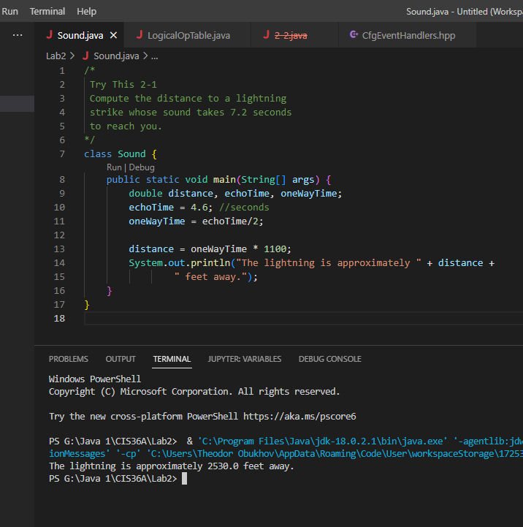
2. TRY THIS 2-2 - Page 69. 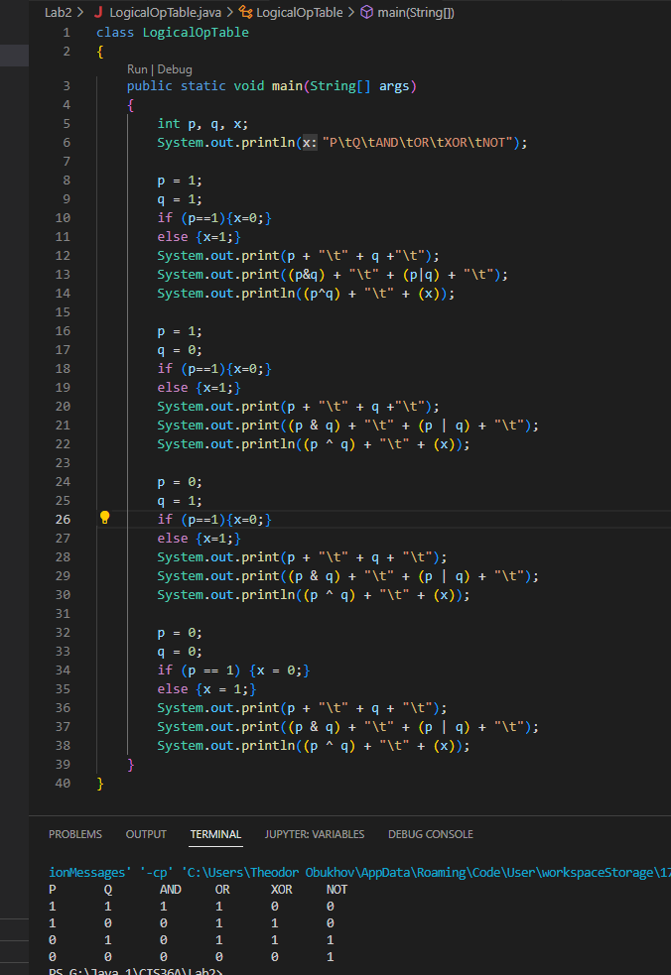
3. Write a program that assigns the value **50000** to an integer variable **x**, assigns the value of **x*x** to an integer variable y, and then prints out the value of y. Did you get a strange answer? If so, explain why. The integer data type can only hold around 2 billion and some change of value, or 32 bits of memory. 50,000 x 50,000 comes with a value greater then the max value of an integer and integer overflow occurs. 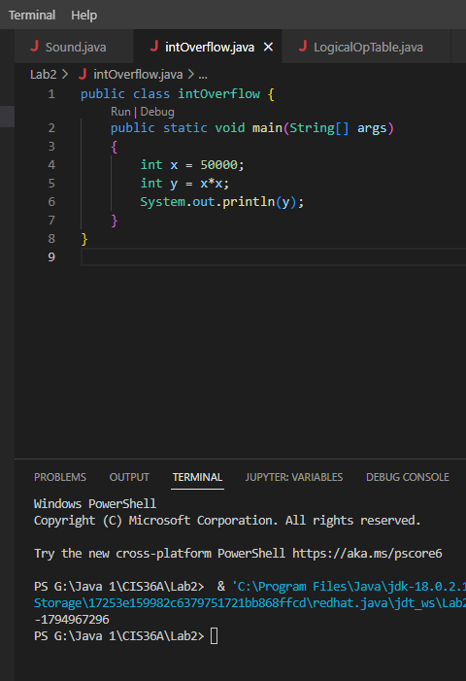
4. **Math.random()** is a method in the Java library that computes a random **double** value between 0 and 1. For example, the statement **double x = Math.random();** assigns to the variable x a random double between 0 and 1.   
   Write a program that tests how well Math.random() works. More precisely, write a program that calls **Math.random()** 1,000 times to create 1,000 values, keeping track of how many of them are greater than 0.5, and then prints out the result. Your program should theoretically print out a number very close to 500. 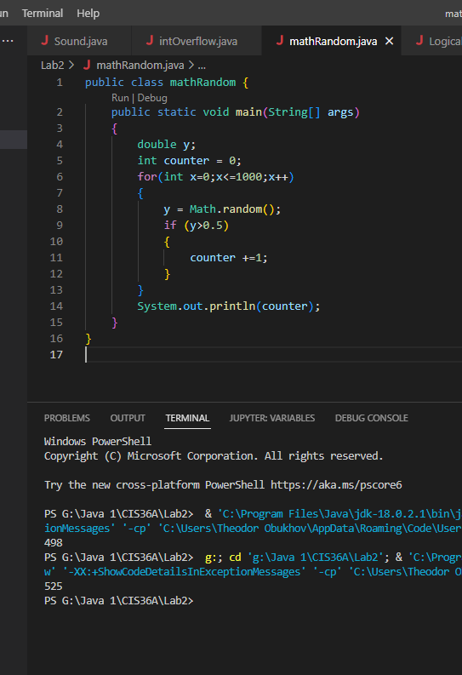
5. Write a program that creates three random double variables a, b, and c and assigns them values between 0 and 1 using the Math.random() method mentioned in the preceding exercise. It then does all of the following:
   1. It prints "All are tiny" if all three values are less than 0.5.
   2. It prints out "One is tiny" if **exactly** one of the three values is less than 0.5.
   3. It prints out "Only two are tiny" if exactly two of the three values are less than 0.5.
   4. it prints “None is tiny” if none of the values are less than 0.5.

**Note: Make sure to use compound boolean statements instead of if-else chains or a count variable.**

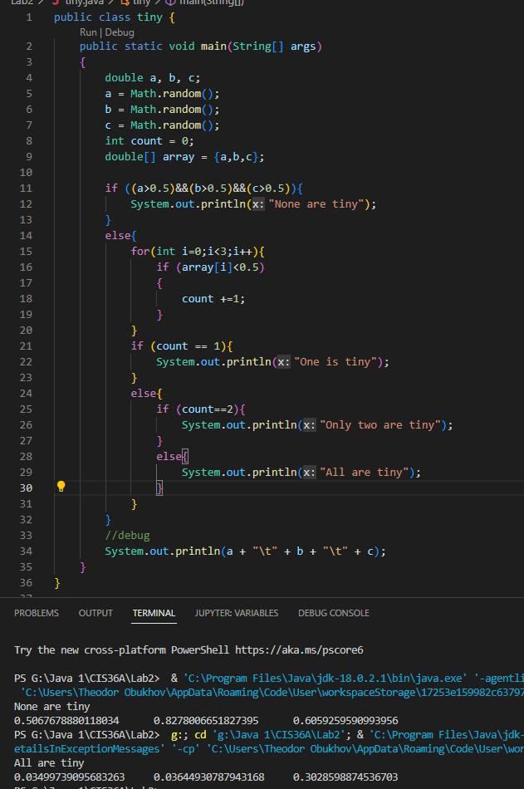

**Task 4: Programming Application**

**Change Calculator:** Write a program that prompts the user to enter a dollar amount as double. Then, calculate how many quarters, dimes, nickels and pennies are in the dollar amount.   
**For example:** $2.68 = 10 quarters, 1 dime, 1 nickel and 3 cents. Print all of the values.   
**Hint:** Use Modulus operator (%) and integer division (/) when necessary. 